Dr Erwin Schurr
Lab 12 Lecture – Polymerase Chain Reaction
March 5, 2006

NOTE: This NTC is meant to be used as a study aid to supplement your own class notes. Hence, not all of the text or diagrams contained in the lecture slides will be reproduced here.
Please send any comments or questions about NTCs to either Misha or James through e-mail at bugs_u2reps@yahoo.ca

PCR (Polymerase Chain Reaction) is a technique for amplification of genetic sequences.
The reaction mix contains DNA polymerases, dNTPs and specific primers.

- Typical temperature cycle:
- Denaturation. Start with a few minutes at 94°C, when double stranded DNA is denatured and is available for hybridization with primers.
- Annealing. The temperature is reduced to approximately 40°C, during which specific oligonucleotide primers anneal to their complementary sequences in the denatured DNA molecules. This happens fast, since the primers are usually fairly short.
- Polymerization. Approximately 72°C degrees. Taq polymerize is used from DNA polymerization. This thermal bacterial protein functions best at elevated temperatures.
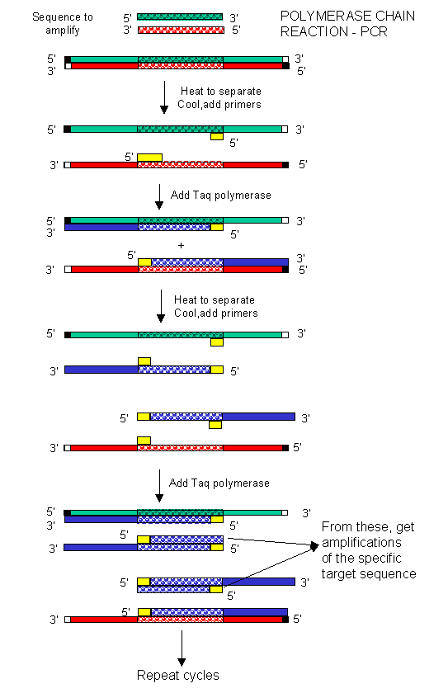
- Individual plateaus are called steps. The time between the steps can be adjusted.
- Amount of cycles can also be adjusted.
- In a typical DNA amplification, 20-30 cycles are used, while you can go up to 50-55 for single-molecule amplification (eg. in spermtyping). The temperatures are regulated by a machine called thermocycler.

- Primers determine the start and end of the sequence to be amplified. More specifically, the 5’ end of the primers determines the end-points of the sequence. The direction of the primers is important since the DNA polymerization only occurs 5’ to 3’. When given a sequence, its complimentary primer will be antiparallel.
- During the first cycle, DNA is polymerized until the DNA polymerase runs off.
- During the second cycle, for half of the strands DNA polymerase runs off, just like in the first cycle. But for the strands synthesized in the first cycle, the newly synthesized DNA only contains the sequence of interest.
- Only by the end of the third cycle, the first double stranded DNA of the sequence of interest has been generated
- This sequence is amplified geometrically in subsequent cycles, while the strands with flanking sequences are amplified linearly

Different components of PCR:
DNA
- Usually dsDNA, but can also use RNA or ssDNA
- Very little DNA is required to start the reaction, as little as a single molecule
- Because of high specificity of primers, the starting DNA can be of poor quality. Degradation of DNA is not a problem, since the amplified sequences are usually really small.
- BUT: Because the PCR is so sensitive, contamination of the amplification reaction is very easy. The smaller the quantity of DNA amplified, the easier it is to contaminate.

Primers
- Also referred to as amplimers or oligos
- Usually 20-25 nucleotides long, but can vary with length depending on need
- Primers must be directed towards each other in an amplification. This is the only place in PCR procedure where one can make a mistake.
- Primer concentration can be determined from the Beer-Lambert law. The usual concentration during a PCR reaction is 1uM
- The annealing temperature has to be carefully selected, depending on the primer used. G:C base pairs are more stable than the A:T base pairs, so if the primer is G:C rich, the annealing temperature is higher.
- The annealing temperature can be estimated using the following formula:
T = (# of A:T base pairs)*2+(# of G:C base pairs)*4
- The more stringent the annealing temperature, the higher the specificity of annealing

DNA Polymerase
- Back in the day, E.coli DNA polymerase was used for PCR, so additional enzyme had to be added after each denaturation step
- Taq polymerase is obtained from a thermophile bacterium. It is stable at higher temperatures required for denaturation. Taq polymerase works optimally at 72°C.
- The advent of Taq polymerase has allowed the automation of PCR reactions
- Now, multiple polymerases have been developed with different characteristics to suit specific PCR reaction needs.
  - Eg. Taq has a 5’->3’ exonuclease activity, but no 3’->5’ exonuclease activity, so it cannot proofread the polymerized chain. The error rate of Taq is rather high. Newer polymerases have been developed with 3’->5’ exonuclease activity. Although the speed of polymerization is reduced, the accuracy is greatly increased with these newer polymerises.
  - The processivity, or rate of polymerization, is not that high, so PCR cannot be used to amplify large DNA sequences (10kb)
  - The polymerase may or may not have a reverse transcriptase activity
  - There may be a specific base or bases that the polymerase places on the 3’ end of the amplicon. This is important to know, if the amplified fragments need to be cloned. For example, some polymerases introduce an A on the 3’ end.
Buffer
- Tris Buffer with MgCl₂
- Mg²⁺ is a co-factor for DNA polymerase, so its presence is important
- Mg²⁺ concentration is usually varied if the PCR reaction doesn’t work.
- The less Mg²⁺ used, the fewer products, but the specificity is better. The more Mg²⁺, the more background unspecific amplification.
- Mg²⁺ forms complexes with dNTPs

dNTPs – in necessary concentrations, depending on the reaction

Efficiency
- The efficiency of a PCR amplification is usually around 85%. This is a result of a plateau effect – attenuation of exponential growth at later cycles of the reaction
- There are two reasons for decreasing efficiency: depletion of dNTPs and primers and instability of reactants (dNTPs decompose at high temperatures, the enzymes lose activity)
- There is also unspecific binding of primers
- At very high DNA concentrations, DNA does not denature completely
- BUT: For exam purposes, the efficiency is assumed to be 100%. To calculate the number of fragments after amplification, use 2^{n}, where n is the number of cycles.

Uses of PCR
Sex determination
- The sequence of a particular gene is different on X and Y chromosomes – in this lab, amelogenin gene has a deletion in its Y chromosome allele
- When the amplification is done with the primers flanking the gene, the product from the X chromosome will be longer than the product from the Y chromosome, which can be visualized on an agarose gel
- If the DNA sample was from a female, there will be one band on the gel (two X-alleles are the same), while the male DNA will produce two bands (X and Y-chromosome alleles are different length)
- The sex can thus be determined

Real Time PCR
- Quantitative PCR technique
- All the reagents are the same as in the regular PCR. The only difference is that you will be monitoring the production of the amplicon during the reaction, not just at the end
- Quantification is complicated using regular PCR, since the plateau phase is reached, and the production of amplicons is no longer linear after a certain number of cycles
- Quantification is often needed to determine the number of cycles required for a particular amplification
- The amount of DNA in the reaction is monitored using fluorescent dyes, which can bind DNA.
- In this lab, a dye called SYBR green is used, which binds to double stranded DNA, but not single stranded. Thus, when DNA is hybridized (single stranded) the fluorescence levels are very low. When DNA is double stranded, the fluorescence levels are 1000x higher.
- Note that SYBR is not a sequence specific dye, so if contaminating DNA exists, the fluorescence level will not correspond to the amount of DNA present. Other dyes are available, which are sequence specific.
- The sample in real time PCR is placed into thin borosilicate capillaries, which allows very rapid cooling and heating of samples during the reaction by an air stream (20°C per second). As a result, a typical real time PCR cycle lasts only about 2 minutes, compared to 30 minutes for regular PCR.
- During the PCR, the fluorescence levels are measured during the elongation step of each cycle (DNA is double stranded) and a computer compiles the data into an amplification plot
- Amplification plot is a fluorescence level vs cycle time plot, which ends as a plateau. It can be used to generate the cycle threshold (CT) value, which is the cycle at which fluorescence is statistically above the background
- CT is inversely proportional to the log of the initial number of template molecules
- If a standard curve is constructed by plotting cycle number vs log concentration for known standards, the initial concentration for an unknown may be determined from the CT value
- Melting curve analysis is performed at the end of PCR, to assess the quality of the amplified product
- Since the fluorescence of SYBR drops dramatically as the DNA is melted into single strands, it is possible to determine the melting temperature. If the rate of change in fluorescence is plotted against temperature, the resulting peak corresponds to the melting temperature. If there is more than one peak, observed, there is more than one DNA type in the sample

Application
- Diagnostics – used to identify copy number alterations, used to quantify the bacterial load in a particular sample
- Research – determining expression levels of a particular gene, looking at mRNA abundance. Can put the sample at different conditions.

